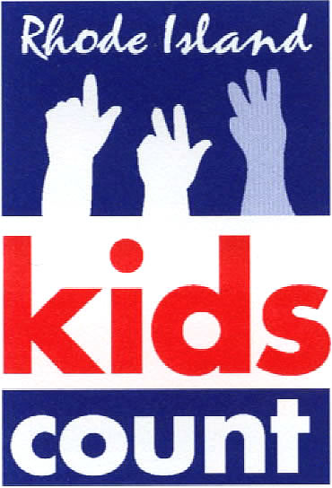
Comments Regarding Proposed Changes to Rules and Regulations of the Rhode Island Training School (214-RICR-60-00-1)
February 19, 2026
Kelsey Bala, Senior Policy Associate
Rhode Island KIDS COUNT

Thank you for the opportunity to review and provide comments on the proposed revisions to the Rules and Regulations of the Rhode Island Training School. We believe the proposed revisions are an important step to maintain the dignity of the youth served by this division.
We strongly support this amendment that updates the division title referenced throughout the regulation from “Division of Juvenile Correctional Services” to “Division of Youth Development.” We recognize the purpose of the amendment is to align the name with their established mission. In recent years, we have seen many other partners make the important decision to update outdated language. In 2024, the National Juvenile Justice Network updated their name to the National Youth Justice Network and cited a similar rationale – the term juvenile is regressive and does not reflect their work to empower youth.

In the 2025 Rhode Island KIDS COUNT Factbook, we changed the name of our youth justice indicator from “Youth in the Juvenile Justice System” to “Youth in the Justice System.” It may seem like a small change, but the language we use to talk about our children matters, and our words carry immense weight. There are negative connotations attached to the word “juvenile”, and while the term stems from a legal distinction, its current subtext strips away the dignity of our youth, and disproportionately Youth of Color. We want the words we use to empower youth who are caught up in different systems. When we use the word youth or child, or address someone by their name, it is humanizing. The last thing we would want is for kids who are caught up in these systems not to have that part of them centered.

Rhode Island KIDS COUNT is in strong support of this name change for the Division of Youth Development. We advocate for the best interest of children using data and research. It is our job to review proposed regulations and legislation and advocate to prevent changes that could harm children and to encourage changes that would support children’s health, safety, and development.


Thank you for your commitment to updating and improving this regulation. Please do not hesitate to contact us with any questions.

